**Representation of the Bass Diffusion Model using Cell-DEVS**

*By:*

**Ardeshir Golshani, St. #: 100631620**

**Ismaeel Al Ridhawi, St. #: 3385278**

**Introduction**

The Bass Diffusion Model uses the following formula to model the adoption and diffusion of new products and technologies which then are used for market analysis and demand forecasting of new technologies.

Standard Bass formula for the diffusion of innovations

Where,

* N*t* indicates the number of users of the product at time *t*.
* *m* indicates the total number of people who will eventually use the product.
* *p* indicates the likelihood that somebody who is not yet using the product will start using it because of mass media coverage or other external factors
* *q* indicates the likelihood that somebody who is not yet using the product will start using it because of "word-of-mouth" or other influence from those already using the product.

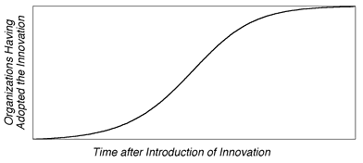

Figure 1: The standard Bass curve for the diffusion of innovations over time

**The Rules**

From [1], we see that to model this using cellular Automata we must use the following rules:

1. A cell’s state is either equal to 1 or 0, where 1 means that a person is using the product and 0 means that a person is not using the product.
2. If a cell’s state is equal to 1 at time t, then the cell will keep its state equal to 1 at time t+1.
3. If a cell’s state is equal to 0 at time t, then the cell’s state will change to 1 at time t+1 with probability :



* where n(t) is the cumulative number of adopters in the neighbourhood of the cell at time t.
* k is the ceiling of neighbours, which in our case is 24 neighbours.
* p is the coefficient of innovation equal to P.
* q is the coefficient of imitation equal to Q.

|  |  |  |  |  |  |  |
| --- | --- | --- | --- | --- | --- | --- |
|  |  |  |  |  |  |  |
|  |  |  |  |  |  |  |
|  |  |  |  |  |  |  |
|  |  |  |  |  |  |  |
|  |  |  |  |  |  |  |
|  |  |  |  |  |  |  |
|  |  |  |  |  |  |  |

Figure 2: A user cell and its influencing neighbours

**The Model**

Our Model of the Bass Diffusion consists of four properties:

1. Wrapped, usually it should be infinite in size, but due to limitations due to the time consumption CD++ requires to simulate, we will use a 2-D regular uniform lattice (23 x 23) to represent the area where innovation diffuses.
2. Cells, each one representing a potential adopter, which can accept discrete values representing various states. Each potential customer can be in one of two states: “0”, customer did not adopt the innovation, “1”, customer adopted the innovation.
3. Neighbourhood, the neighbourhood is a Moor neighbourhood with radius 2.
4. Transition rules, the variables at each site are updated simultaneously, based on the values of the variables in their neighbors at the preceding time step, and according to the definite set of “local rules”. As in Bass model, a potential adopter’s probability of innovation adoption at time *t* depends on two forces: 1) External influence: There is some probability *p* that in a certain time period, an individual will be influenced by external influence mechanisms such as advertising or mass media to adopt the innovation, We begin by setting this probability to be constant across potential adopters and time, and 2) Internal influences: There is some probability that during a single. Time period; a person will be affected by interactions with others who have already adopted the product. We represent the probability that a person will be affected by an interaction with one other person in his neighborhood as *q.* In the case of this model, q is constant for all potential adopters. Also, irreversibility of transition is assumed, so that customers cannot “un-adopt” after adoption. *An* underlying assumption is that all potential adopters are only capable of interaction with their neighbors. [1]

p = 0.00255,

q = 0.13052,

k = 24

Therefore in order for a cell to change state from 0 to 1, its probability must be bigger than 0.051, which is 38.3% of the formula.

**Formal Specification**

## External Coupling Definition

**M = < X, Y, D, {Mi}, {Ii}, {Zij}, select>**

We have no external coupling with any outside world. So I am not defining this portion of formalism.

## Atomic Cell Devs Model

M=<I,X,Y,Xlist,Ylist,η, N,{m,n}, C, B, Z, select>

Xlist=Φ

Ylist=Φ

η=24

I=<PX,Py>,with PX={Φ},Py={Φ};

N={ (-2,-2), (-2,-1), (-2,0), (-2,1), (-2,2), (-1,-2), (-1,-1), (-1,0), (-1,1), (-1,2), (0,-2), (0,-1), (0,0), (0,1), (0,2), (1,-2), (1,-1), (1,0), (1,1), (1,2), (2,-2), (2,-1), (2,0), (2,1), (2,2) }

***X*** = {0, 1};

***Y*** = {0, 1};

M = 23;

N = 23;

B={Φ};

C={Cij/iε[1,20], jε[1,20]}

Z:

Pij X1 ← Pi,j+1 Y1

Pij X2 ← Pi,j+2 Y2

Pij X3 ← Pi,j-1 Y3

Pij X4 ← Pi,j-2 Y4

Pij X5 ← Pi+1,j Y5

Pij X6 ← Pi+2,j Y6

Pij X7 ← Pi-1,j Y7

Pij X8 ← Pi-2,j Y8

Pij X9 ← Pi-1,j-1 Y9

Pij X10 ← Pi-1,j-2 Y10

Pij X11 ← Pi-2,j-1 Y11

Pij X12 ← Pi-2,j-2 Y12

Pij X13 ← Pi+1,j-1 Y13

Pij X14 ← Pi+1,j-2 Y14

Pij X15 ← Pi+2,j-1 Y15

Pij X16 ← Pi+2,j-2 Y16

Pij X17 ← Pi-1,j+1 Y17

Pij X18 ← Pi-1,j+2 Y18

Pij X19 ← Pi-2,j+1 Y19

Pij X20 ← Pi-2,j+2 Y20

Pij X21 ← Pi+1,j+1 Y21

Pij X22 ← Pi+1,j+2 Y22

Pij X23 ← Pi+2,j+1 Y23

Pij X24 ← Pi+2,j+2 Y24

Select={ (-2,-2), (-2,-1), (-2,0), (-2,1), (-2,2), (-1,-2), (-1,-1), (-1,0), (-1,1), (-1,2), (0,-2), (0,-1), (0,0), (0,1), (0,2), (1,-2), (1,-1), (1,0), (1,1), (1,2), (2,-2), (2,-1), (2,0), (2,1), (2,2) }

**Simulation and Testing**

The following shows how an innovation is adopted throughout the environment by people:

Line : 1071 - Time: 00:00:00:000

0 1 2 3 4 5 6 7 8 9 10 11 12 13 14 15 16 17 18 19 20 21 22

+---------------------------------------------------------------------+

0| |

1| |

2| |

3| 1 1 1 1 1 |

4| 1 1 1 1 1 |

5| 1 1 1 1 |

6| 1 1 1 1 1 |

7| 1 1 1 1 1 |

8| |

9| |

10| |

11| |

12| |

13| |

14| |

15| |

16| |

17| |

18| |

19| |

20| |

21| |

22| |

+---------------------------------------------------------------------+

Line : 1263 - Time: 00:00:00:100

0 1 2 3 4 5 6 7 8 9 10 11 12 13 14 15 16 17 18 19 20 21 22

+---------------------------------------------------------------------+

0| |

1| |

2| 1 |

3| 1 1 1 1 1 |

4| 1 1 1 1 1 |

5| 1 1 1 1 1 1 1 |

6| 1 1 1 1 1 |

7| 1 1 1 1 1 |

8| 1 |

9| |

10| |

11| |

12| |

13| |

14| |

15| |

16| |

17| |

18| |

19| |

20| |

21| |

22| |

+---------------------------------------------------------------------+

Line : 1499 - Time: 00:00:00:200

0 1 2 3 4 5 6 7 8 9 10 11 12 13 14 15 16 17 18 19 20 21 22

+---------------------------------------------------------------------+

0| |

1| |

2| 1 1 1 |

3| 1 1 1 1 1 |

4| 1 1 1 1 1 1 1 |

5| 1 1 1 1 1 1 1 |

6| 1 1 1 1 1 1 1 |

7| 1 1 1 1 1 |

8| 1 1 1 |

9| |

10| |

11| |

12| |

13| |

14| |

15| |

16| |

17| |

18| |

19| |

20| |

21| |

22| |

+---------------------------------------------------------------------+

Line : 1763 - Time: 00:00:00:300

0 1 2 3 4 5 6 7 8 9 10 11 12 13 14 15 16 17 18 19 20 21 22

+---------------------------------------------------------------------+

0| |

1| |

2| 1 1 1 1 1 |

3| 1 1 1 1 1 1 1 |

4| 1 1 1 1 1 1 1 |

5| 1 1 1 1 1 1 1 |

6| 1 1 1 1 1 1 1 |

7| 1 1 1 1 1 1 1 |

8| 1 1 1 1 1 |

9| |

10| |

11| |

12| |

13| |

14| |

15| |

16| |

17| |

18| |

19| |

20| |

21| |

22| |

+---------------------------------------------------------------------+

Line : 2051 - Time: 00:00:00:400

0 1 2 3 4 5 6 7 8 9 10 11 12 13 14 15 16 17 18 19 20 21 22

+---------------------------------------------------------------------+

0| |

1| 1 1 1 |

2| 1 1 1 1 1 |

3| 1 1 1 1 1 1 1 |

4| 1 1 1 1 1 1 1 1 1 |

5| 1 1 1 1 1 1 1 1 1 |

6| 1 1 1 1 1 1 1 1 1 |

7| 1 1 1 1 1 1 1 |

8| 1 1 1 1 1 |

9| 1 1 1 |

10| |

11| |

12| |

13| |

14| |

15| |

16| |

17| |

18| |

19| |

20| |

21| |

22| |

+---------------------------------------------------------------------+

Line : 2403 - Time: 00:00:00:500

0 1 2 3 4 5 6 7 8 9 10 11 12 13 14 15 16 17 18 19 20 21 22

+---------------------------------------------------------------------+

0| |

1| 1 1 1 1 1 |

2| 1 1 1 1 1 1 1 |

3| 1 1 1 1 1 1 1 1 1 |

4| 1 1 1 1 1 1 1 1 1 |

5| 1 1 1 1 1 1 1 1 1 |

6| 1 1 1 1 1 1 1 1 1 |

7| 1 1 1 1 1 1 1 1 1 |

8| 1 1 1 1 1 1 1 |

9| 1 1 1 1 1 |

10| |

11| |

12| |

13| |

14| |

15| |

16| |

17| |

18| |

19| |

20| |

21| |

22| |

+---------------------------------------------------------------------+

Line : 2815 - Time: 00:00:00:600

0 1 2 3 4 5 6 7 8 9 10 11 12 13 14 15 16 17 18 19 20 21 22

+---------------------------------------------------------------------+

0| 1 1 1 |

1| 1 1 1 1 1 1 1 |

2| 1 1 1 1 1 1 1 1 1 |

3| 1 1 1 1 1 1 1 1 1 |

4| 1 1 1 1 1 1 1 1 1 1 1 |

5| 1 1 1 1 1 1 1 1 1 1 1 |

6| 1 1 1 1 1 1 1 1 1 1 1 |

7| 1 1 1 1 1 1 1 1 1 |

8| 1 1 1 1 1 1 1 1 1 |

9| 1 1 1 1 1 1 1 |

10| 1 1 1 |

11| |

12| |

13| |

14| |

15| |

16| |

17| |

18| |

19| |

20| |

21| |

22| |

+---------------------------------------------------------------------+

Line : 3187 - Time: 00:00:00:700

0 1 2 3 4 5 6 7 8 9 10 11 12 13 14 15 16 17 18 19 20 21 22

+---------------------------------------------------------------------+

0| 1 1 1 1 1 |

1| 1 1 1 1 1 1 1 |

2| 1 1 1 1 1 1 1 1 1 |

3| 1 1 1 1 1 1 1 1 1 1 1 |

4| 1 1 1 1 1 1 1 1 1 1 1 |

5| 1 1 1 1 1 1 1 1 1 1 1 |

6| 1 1 1 1 1 1 1 1 1 1 1 |

7| 1 1 1 1 1 1 1 1 1 1 1 |

8| 1 1 1 1 1 1 1 1 1 |

9| 1 1 1 1 1 1 1 |

10| 1 1 1 1 1 |

11| |

12| |

13| |

14| |

15| |

16| |

17| |

18| |

19| |

20| |

21| |

22| |

+---------------------------------------------------------------------+

Line : 3687 - Time: 00:00:00:800

0 1 2 3 4 5 6 7 8 9 10 11 12 13 14 15 16 17 18 19 20 21 22

+---------------------------------------------------------------------+

0| 1 1 1 1 1 1 1 |

1| 1 1 1 1 1 1 1 1 1 |

2| 1 1 1 1 1 1 1 1 1 1 1 |

3| 1 1 1 1 1 1 1 1 1 1 1 |

4| 1 1 1 1 1 1 1 1 1 1 1 1 1|

5| 1 1 1 1 1 1 1 1 1 1 1 1 1|

6| 1 1 1 1 1 1 1 1 1 1 1 1 1|

7| 1 1 1 1 1 1 1 1 1 1 1 |

8| 1 1 1 1 1 1 1 1 1 1 1 |

9| 1 1 1 1 1 1 1 1 1 |

10| 1 1 1 1 1 1 1 |

11| 1 1 1 |

12| |

13| |

14| |

15| |

16| |

17| |

18| |

19| |

20| |

21| |

22| 1 1 1 |

+---------------------------------------------------------------------+

Line : 4183 - Time: 00:00:00:900

0 1 2 3 4 5 6 7 8 9 10 11 12 13 14 15 16 17 18 19 20 21 22

+---------------------------------------------------------------------+

0| 1 1 1 1 1 1 1 1 1 |

1| 1 1 1 1 1 1 1 1 1 1 1 |

2| 1 1 1 1 1 1 1 1 1 1 1 |

3| 1 1 1 1 1 1 1 1 1 1 1 1 1|

4| 1 1 1 1 1 1 1 1 1 1 1 1 1|

5| 1 1 1 1 1 1 1 1 1 1 1 1 1|

6| 1 1 1 1 1 1 1 1 1 1 1 1 1|

7| 1 1 1 1 1 1 1 1 1 1 1 1 1|

8| 1 1 1 1 1 1 1 1 1 1 1 |

9| 1 1 1 1 1 1 1 1 1 1 1 |

10| 1 1 1 1 1 1 1 1 1 |

11| 1 1 1 1 1 |

12| |

13| |

14| |

15| |

16| |

17| |

18| |

19| |

20| |

21| |

22| 1 1 1 1 1 |

+---------------------------------------------------------------------+

Line : 4703 - Time: 00:00:01:000

0 1 2 3 4 5 6 7 8 9 10 11 12 13 14 15 16 17 18 19 20 21 22

+---------------------------------------------------------------------+

0| 1 1 1 1 1 1 1 1 1 |

1| 1 1 1 1 1 1 1 1 1 1 1 |

2| 1 1 1 1 1 1 1 1 1 1 1 1 1|

3| 1 1 1 1 1 1 1 1 1 1 1 1 1|

4| 1 1 1 1 1 1 1 1 1 1 1 1 1 1 1|

5| 1 1 1 1 1 1 1 1 1 1 1 1 1 1 1|

6| 1 1 1 1 1 1 1 1 1 1 1 1 1 1 1|

7| 1 1 1 1 1 1 1 1 1 1 1 1 1|

8| 1 1 1 1 1 1 1 1 1 1 1 1 1|

9| 1 1 1 1 1 1 1 1 1 1 1 |

10| 1 1 1 1 1 1 1 1 1 |

11| 1 1 1 1 1 1 1 |

12| 1 1 1 |

13| |

14| |

15| |

16| |

17| |

18| |

19| |

20| |

21| 1 1 1 |

22| 1 1 1 1 1 1 1 |

+---------------------------------------------------------------------+

Line : 5287 - Time: 00:00:01:100

0 1 2 3 4 5 6 7 8 9 10 11 12 13 14 15 16 17 18 19 20 21 22

+---------------------------------------------------------------------+

0| 1 1 1 1 1 1 1 1 1 1 1 |

1| 1 1 1 1 1 1 1 1 1 1 1 1 1|

2| 1 1 1 1 1 1 1 1 1 1 1 1 1|

3| 1 1 1 1 1 1 1 1 1 1 1 1 1 1 1|

4| 1 1 1 1 1 1 1 1 1 1 1 1 1 1 1|

5| 1 1 1 1 1 1 1 1 1 1 1 1 1 1 1|

6| 1 1 1 1 1 1 1 1 1 1 1 1 1 1 1|

7| 1 1 1 1 1 1 1 1 1 1 1 1 1 1 1|

8| 1 1 1 1 1 1 1 1 1 1 1 1 1|

9| 1 1 1 1 1 1 1 1 1 1 1 1 1|

10| 1 1 1 1 1 1 1 1 1 1 1 |

11| 1 1 1 1 1 1 1 1 1 |

12| 1 1 1 1 1 |

13| |

14| |

15| |

16| |

17| |

18| |

19| |

20| |

21| 1 1 1 1 1 |

22| 1 1 1 1 1 1 1 1 1 |

+---------------------------------------------------------------------+

Line : 5939 - Time: 00:00:01:200

0 1 2 3 4 5 6 7 8 9 10 11 12 13 14 15 16 17 18 19 20 21 22

+---------------------------------------------------------------------+

0| 1 1 1 1 1 1 1 1 1 1 1 1 1|

1| 1 1 1 1 1 1 1 1 1 1 1 1 1|

2| 1 1 1 1 1 1 1 1 1 1 1 1 1 1 1|

3| 1 1 1 1 1 1 1 1 1 1 1 1 1 1 1|

4| 1 1 1 1 1 1 1 1 1 1 1 1 1 1 1 1 1|

5| 1 1 1 1 1 1 1 1 1 1 1 1 1 1 1 1 1|

6| 1 1 1 1 1 1 1 1 1 1 1 1 1 1 1 1 1|

7| 1 1 1 1 1 1 1 1 1 1 1 1 1 1 1|

8| 1 1 1 1 1 1 1 1 1 1 1 1 1 1 1|

9| 1 1 1 1 1 1 1 1 1 1 1 1 1|

10| 1 1 1 1 1 1 1 1 1 1 1 1 1|

11| 1 1 1 1 1 1 1 1 1 1 1 |

12| 1 1 1 1 1 1 1 |

13| 1 1 1 |

14| |

15| |

16| |

17| |

18| |

19| |

20| 1 1 1 |

21| 1 1 1 1 1 1 1 |

22| 1 1 1 1 1 1 1 1 1 1 1 |

+---------------------------------------------------------------------+

Line : 6583 - Time: 00:00:01:300

0 1 2 3 4 5 6 7 8 9 10 11 12 13 14 15 16 17 18 19 20 21 22

+---------------------------------------------------------------------+

0| 1 1 1 1 1 1 1 1 1 1 1 1 1|

1| 1 1 1 1 1 1 1 1 1 1 1 1 1 1 1|

2| 1 1 1 1 1 1 1 1 1 1 1 1 1 1 1 1 1|

3| 1 1 1 1 1 1 1 1 1 1 1 1 1 1 1 1 1|

4| 1 1 1 1 1 1 1 1 1 1 1 1 1 1 1 1 1|

5| 1 1 1 1 1 1 1 1 1 1 1 1 1 1 1 1 1|

6| 1 1 1 1 1 1 1 1 1 1 1 1 1 1 1 1 1|

7| 1 1 1 1 1 1 1 1 1 1 1 1 1 1 1 1 1|

8| 1 1 1 1 1 1 1 1 1 1 1 1 1 1 1 1 1|

9| 1 1 1 1 1 1 1 1 1 1 1 1 1 1 1|

10| 1 1 1 1 1 1 1 1 1 1 1 1 1|

11| 1 1 1 1 1 1 1 1 1 1 1 |

12| 1 1 1 1 1 1 1 1 1 |

13| 1 1 1 1 1 1 1 |

14| |

15| |

16| |

17| |

18| |

19| |

20| 1 1 1 1 1 1 1 |

21| 1 1 1 1 1 1 1 1 1 |

22| 1 1 1 1 1 1 1 1 1 1 1 |

+---------------------------------------------------------------------+

Line : 7359 - Time: 00:00:01:400

0 1 2 3 4 5 6 7 8 9 10 11 12 13 14 15 16 17 18 19 20 21 22

+---------------------------------------------------------------------+

0| 1 1 1 1 1 1 1 1 1 1 1 1 1 1 1|

1| 1 1 1 1 1 1 1 1 1 1 1 1 1 1 1 1 1|

2| 1 1 1 1 1 1 1 1 1 1 1 1 1 1 1 1 1|

3| 1 1 1 1 1 1 1 1 1 1 1 1 1 1 1 1 1 1 1|

4| 1 1 1 1 1 1 1 1 1 1 1 1 1 1 1 1 1 1 1|

5| 1 1 1 1 1 1 1 1 1 1 1 1 1 1 1 1 1 1 1|

6| 1 1 1 1 1 1 1 1 1 1 1 1 1 1 1 1 1 1 1|

7| 1 1 1 1 1 1 1 1 1 1 1 1 1 1 1 1 1 1 1|

8| 1 1 1 1 1 1 1 1 1 1 1 1 1 1 1 1 1|

9| 1 1 1 1 1 1 1 1 1 1 1 1 1 1 1 1 1|

10| 1 1 1 1 1 1 1 1 1 1 1 1 1 1 1|

11| 1 1 1 1 1 1 1 1 1 1 1 1 1|

12| 1 1 1 1 1 1 1 1 1 1 1 |

13| 1 1 1 1 1 1 1 1 1 |

14| 1 1 1 1 1 |

15| |

16| |

17| |

18| |

19| 1 1 1 1 1 |

20| 1 1 1 1 1 1 1 1 1 |

21| 1 1 1 1 1 1 1 1 1 1 1 |

22| 1 1 1 1 1 1 1 1 1 1 1 1 1|

+---------------------------------------------------------------------+

Line : 8139 - Time: 00:00:01:500

0 1 2 3 4 5 6 7 8 9 10 11 12 13 14 15 16 17 18 19 20 21 22

+---------------------------------------------------------------------+

0| 1 1 1 1 1 1 1 1 1 1 1 1 1 1 1 1 1|

1| 1 1 1 1 1 1 1 1 1 1 1 1 1 1 1 1 1|

2| 1 1 1 1 1 1 1 1 1 1 1 1 1 1 1 1 1 1 1|

3| 1 1 1 1 1 1 1 1 1 1 1 1 1 1 1 1 1 1 1|

4| 1 1 1 1 1 1 1 1 1 1 1 1 1 1 1 1 1 1 1 1 1|

5| 1 1 1 1 1 1 1 1 1 1 1 1 1 1 1 1 1 1 1 1 1|

6| 1 1 1 1 1 1 1 1 1 1 1 1 1 1 1 1 1 1 1 1 1|

7| 1 1 1 1 1 1 1 1 1 1 1 1 1 1 1 1 1 1 1|

8| 1 1 1 1 1 1 1 1 1 1 1 1 1 1 1 1 1 1 1|

9| 1 1 1 1 1 1 1 1 1 1 1 1 1 1 1 1 1|

10| 1 1 1 1 1 1 1 1 1 1 1 1 1 1 1 1 1|

11| 1 1 1 1 1 1 1 1 1 1 1 1 1 1 1|

12| 1 1 1 1 1 1 1 1 1 1 1 1 1|

13| 1 1 1 1 1 1 1 1 1 1 1 |

14| 1 1 1 1 1 1 1 |

15| 1 1 1 |

16| |

17| |

18| 1 1 1 |

19| 1 1 1 1 1 1 1 |

20| 1 1 1 1 1 1 1 1 1 1 1 |

21| 1 1 1 1 1 1 1 1 1 1 1 1 1|

22| 1 1 1 1 1 1 1 1 1 1 1 1 1 1 1|

+---------------------------------------------------------------------+

Line : 8927 - Time: 00:00:01:600

0 1 2 3 4 5 6 7 8 9 10 11 12 13 14 15 16 17 18 19 20 21 22

+---------------------------------------------------------------------+

0| 1 1 1 1 1 1 1 1 1 1 1 1 1 1 1 1 1|

1| 1 1 1 1 1 1 1 1 1 1 1 1 1 1 1 1 1 1 1|

2| 1 1 1 1 1 1 1 1 1 1 1 1 1 1 1 1 1 1 1 1 1|

3| 1 1 1 1 1 1 1 1 1 1 1 1 1 1 1 1 1 1 1 1 1|

4| 1 1 1 1 1 1 1 1 1 1 1 1 1 1 1 1 1 1 1 1 1 1 1|

5| 1 1 1 1 1 1 1 1 1 1 1 1 1 1 1 1 1 1 1 1 1 1 1|

6| 1 1 1 1 1 1 1 1 1 1 1 1 1 1 1 1 1 1 1 1 1 1 1|

7| 1 1 1 1 1 1 1 1 1 1 1 1 1 1 1 1 1 1 1 1 1|

8| 1 1 1 1 1 1 1 1 1 1 1 1 1 1 1 1 1 1 1 1 1|

9| 1 1 1 1 1 1 1 1 1 1 1 1 1 1 1 1 1 1 1|

10| 1 1 1 1 1 1 1 1 1 1 1 1 1 1 1 1 1|

11| 1 1 1 1 1 1 1 1 1 1 1 1 1 1 1 1 1|

12| 1 1 1 1 1 1 1 1 1 1 1 1 1 1 1|

13| 1 1 1 1 1 1 1 1 1 1 1 1 1|

14| 1 1 1 1 1 1 1 1 1 |

15| 1 1 1 1 1 1 1 |

16| 1 1 1 |

17| 1 1 1 |

18| 1 1 1 1 1 1 1 |

19| 1 1 1 1 1 1 1 1 1 |

20| 1 1 1 1 1 1 1 1 1 1 1 1 1|

21| 1 1 1 1 1 1 1 1 1 1 1 1 1 1 1|

22| 1 1 1 1 1 1 1 1 1 1 1 1 1 1 1 1 1|

+---------------------------------------------------------------------+

Line : 9659 - Time: 00:00:01:700

0 1 2 3 4 5 6 7 8 9 10 11 12 13 14 15 16 17 18 19 20 21 22

+---------------------------------------------------------------------+

0| 1 1 1 1 1 1 1 1 1 1 1 1 1 1 1 1 1 1 1|

1| 1 1 1 1 1 1 1 1 1 1 1 1 1 1 1 1 1 1 1 1 1|

2| 1 1 1 1 1 1 1 1 1 1 1 1 1 1 1 1 1 1 1 1 1 1 1|

3| 1 1 1 1 1 1 1 1 1 1 1 1 1 1 1 1 1 1 1 1 1 1 1|

4| 1 1 1 1 1 1 1 1 1 1 1 1 1 1 1 1 1 1 1 1 1 1 1|

5| 1 1 1 1 1 1 1 1 1 1 1 1 1 1 1 1 1 1 1 1 1 1 1|

6| 1 1 1 1 1 1 1 1 1 1 1 1 1 1 1 1 1 1 1 1 1 1 1|

7| 1 1 1 1 1 1 1 1 1 1 1 1 1 1 1 1 1 1 1 1 1 1 1|

8| 1 1 1 1 1 1 1 1 1 1 1 1 1 1 1 1 1 1 1 1 1 1 1|

9| 1 1 1 1 1 1 1 1 1 1 1 1 1 1 1 1 1 1 1 1 1|

10| 1 1 1 1 1 1 1 1 1 1 1 1 1 1 1 1 1 1 1|

11| 1 1 1 1 1 1 1 1 1 1 1 1 1 1 1 1 1|

12| 1 1 1 1 1 1 1 1 1 1 1 1 1 1 1 1 1|

13| 1 1 1 1 1 1 1 1 1 1 1 1 1 1 1|

14| 1 1 1 1 1 1 1 1 1 1 1 |

15| 1 1 1 1 1 1 1 1 1 |

16| 1 1 1 1 1 1 1 |

17| 1 1 1 1 1 1 1 |

18| 1 1 1 1 1 1 1 1 1 |

19| 1 1 1 1 1 1 1 1 1 1 1 |

20| 1 1 1 1 1 1 1 1 1 1 1 1 1 1 1|

21| 1 1 1 1 1 1 1 1 1 1 1 1 1 1 1 1 1|

22| 1 1 1 1 1 1 1 1 1 1 1 1 1 1 1 1 1|

+---------------------------------------------------------------------+

Line : 10235 - Time: 00:00:01:800

0 1 2 3 4 5 6 7 8 9 10 11 12 13 14 15 16 17 18 19 20 21 22

+---------------------------------------------------------------------+

0| 1 1 1 1 1 1 1 1 1 1 1 1 1 1 1 1 1 1 1 1 1 1 1|

1| 1 1 1 1 1 1 1 1 1 1 1 1 1 1 1 1 1 1 1 1 1 1 1|

2| 1 1 1 1 1 1 1 1 1 1 1 1 1 1 1 1 1 1 1 1 1 1 1|

3| 1 1 1 1 1 1 1 1 1 1 1 1 1 1 1 1 1 1 1 1 1 1 1|

4| 1 1 1 1 1 1 1 1 1 1 1 1 1 1 1 1 1 1 1 1 1 1 1|

5| 1 1 1 1 1 1 1 1 1 1 1 1 1 1 1 1 1 1 1 1 1 1 1|

6| 1 1 1 1 1 1 1 1 1 1 1 1 1 1 1 1 1 1 1 1 1 1 1|

7| 1 1 1 1 1 1 1 1 1 1 1 1 1 1 1 1 1 1 1 1 1 1 1|

8| 1 1 1 1 1 1 1 1 1 1 1 1 1 1 1 1 1 1 1 1 1 1 1|

9| 1 1 1 1 1 1 1 1 1 1 1 1 1 1 1 1 1 1 1 1 1 1 1|

10| 1 1 1 1 1 1 1 1 1 1 1 1 1 1 1 1 1 1 1 1 1 1 1|

11| 1 1 1 1 1 1 1 1 1 1 1 1 1 1 1 1 1 1 1|

12| 1 1 1 1 1 1 1 1 1 1 1 1 1 1 1 1 1|

13| 1 1 1 1 1 1 1 1 1 1 1 1 1 1 1|

14| 1 1 1 1 1 1 1 1 1 1 1 1 1|

15| 1 1 1 1 1 1 1 1 1 1 1 |

16| 1 1 1 1 1 1 1 1 1 1 1 |

17| 1 1 1 1 1 1 1 1 1 1 1 |

18| 1 1 1 1 1 1 1 1 1 1 1 |

19| 1 1 1 1 1 1 1 1 1 1 1 1 1|

20| 1 1 1 1 1 1 1 1 1 1 1 1 1 1 1|

21| 1 1 1 1 1 1 1 1 1 1 1 1 1 1 1 1 1|

22| 1 1 1 1 1 1 1 1 1 1 1 1 1 1 1 1 1 1 1|

+---------------------------------------------------------------------+

Line : 10727 - Time: 00:00:01:900

0 1 2 3 4 5 6 7 8 9 10 11 12 13 14 15 16 17 18 19 20 21 22

+---------------------------------------------------------------------+

0| 1 1 1 1 1 1 1 1 1 1 1 1 1 1 1 1 1 1 1 1 1 1 1|

1| 1 1 1 1 1 1 1 1 1 1 1 1 1 1 1 1 1 1 1 1 1 1 1|

2| 1 1 1 1 1 1 1 1 1 1 1 1 1 1 1 1 1 1 1 1 1 1 1|

3| 1 1 1 1 1 1 1 1 1 1 1 1 1 1 1 1 1 1 1 1 1 1 1|

4| 1 1 1 1 1 1 1 1 1 1 1 1 1 1 1 1 1 1 1 1 1 1 1|

5| 1 1 1 1 1 1 1 1 1 1 1 1 1 1 1 1 1 1 1 1 1 1 1|

6| 1 1 1 1 1 1 1 1 1 1 1 1 1 1 1 1 1 1 1 1 1 1 1|

7| 1 1 1 1 1 1 1 1 1 1 1 1 1 1 1 1 1 1 1 1 1 1 1|

8| 1 1 1 1 1 1 1 1 1 1 1 1 1 1 1 1 1 1 1 1 1 1 1|

9| 1 1 1 1 1 1 1 1 1 1 1 1 1 1 1 1 1 1 1 1 1 1 1|

10| 1 1 1 1 1 1 1 1 1 1 1 1 1 1 1 1 1 1 1 1 1 1 1|

11| 1 1 1 1 1 1 1 1 1 1 1 1 1 1 1 1 1 1 1 1 1 1 1|

12| 1 1 1 1 1 1 1 1 1 1 1 1 1 1 1 1 1 1 1|

13| 1 1 1 1 1 1 1 1 1 1 1 1 1 1 1 1 1|

14| 1 1 1 1 1 1 1 1 1 1 1 1 1 1 1|

15| 1 1 1 1 1 1 1 1 1 1 1 1 1|

16| 1 1 1 1 1 1 1 1 1 1 1 1 1|

17| 1 1 1 1 1 1 1 1 1 1 1 1 1|

18| 1 1 1 1 1 1 1 1 1 1 1 1 1|

19| 1 1 1 1 1 1 1 1 1 1 1 1 1 1 1|

20| 1 1 1 1 1 1 1 1 1 1 1 1 1 1 1 1 1|

21| 1 1 1 1 1 1 1 1 1 1 1 1 1 1 1 1 1 1 1|

22| 1 1 1 1 1 1 1 1 1 1 1 1 1 1 1 1 1 1 1 1 1 1 1|

+---------------------------------------------------------------------+

Line : 11135 - Time: 00:00:02:000

0 1 2 3 4 5 6 7 8 9 10 11 12 13 14 15 16 17 18 19 20 21 22

+---------------------------------------------------------------------+

0| 1 1 1 1 1 1 1 1 1 1 1 1 1 1 1 1 1 1 1 1 1 1 1|

1| 1 1 1 1 1 1 1 1 1 1 1 1 1 1 1 1 1 1 1 1 1 1 1|

2| 1 1 1 1 1 1 1 1 1 1 1 1 1 1 1 1 1 1 1 1 1 1 1|

3| 1 1 1 1 1 1 1 1 1 1 1 1 1 1 1 1 1 1 1 1 1 1 1|

4| 1 1 1 1 1 1 1 1 1 1 1 1 1 1 1 1 1 1 1 1 1 1 1|

5| 1 1 1 1 1 1 1 1 1 1 1 1 1 1 1 1 1 1 1 1 1 1 1|

6| 1 1 1 1 1 1 1 1 1 1 1 1 1 1 1 1 1 1 1 1 1 1 1|

7| 1 1 1 1 1 1 1 1 1 1 1 1 1 1 1 1 1 1 1 1 1 1 1|

8| 1 1 1 1 1 1 1 1 1 1 1 1 1 1 1 1 1 1 1 1 1 1 1|

9| 1 1 1 1 1 1 1 1 1 1 1 1 1 1 1 1 1 1 1 1 1 1 1|

10| 1 1 1 1 1 1 1 1 1 1 1 1 1 1 1 1 1 1 1 1 1 1 1|

11| 1 1 1 1 1 1 1 1 1 1 1 1 1 1 1 1 1 1 1 1 1 1 1|

12| 1 1 1 1 1 1 1 1 1 1 1 1 1 1 1 1 1 1 1 1 1 1 1|

13| 1 1 1 1 1 1 1 1 1 1 1 1 1 1 1 1 1 1 1|

14| 1 1 1 1 1 1 1 1 1 1 1 1 1 1 1 1 1|

15| 1 1 1 1 1 1 1 1 1 1 1 1 1 1 1|

16| 1 1 1 1 1 1 1 1 1 1 1 1 1 1 1|

17| 1 1 1 1 1 1 1 1 1 1 1 1 1 1 1|

18| 1 1 1 1 1 1 1 1 1 1 1 1 1 1 1|

19| 1 1 1 1 1 1 1 1 1 1 1 1 1 1 1 1 1|

20| 1 1 1 1 1 1 1 1 1 1 1 1 1 1 1 1 1 1 1|

21| 1 1 1 1 1 1 1 1 1 1 1 1 1 1 1 1 1 1 1 1 1 1 1|

22| 1 1 1 1 1 1 1 1 1 1 1 1 1 1 1 1 1 1 1 1 1 1 1|

+---------------------------------------------------------------------+

Line : 11463 - Time: 00:00:02:100

0 1 2 3 4 5 6 7 8 9 10 11 12 13 14 15 16 17 18 19 20 21 22

+---------------------------------------------------------------------+

0| 1 1 1 1 1 1 1 1 1 1 1 1 1 1 1 1 1 1 1 1 1 1 1|

1| 1 1 1 1 1 1 1 1 1 1 1 1 1 1 1 1 1 1 1 1 1 1 1|

2| 1 1 1 1 1 1 1 1 1 1 1 1 1 1 1 1 1 1 1 1 1 1 1|

3| 1 1 1 1 1 1 1 1 1 1 1 1 1 1 1 1 1 1 1 1 1 1 1|

4| 1 1 1 1 1 1 1 1 1 1 1 1 1 1 1 1 1 1 1 1 1 1 1|

5| 1 1 1 1 1 1 1 1 1 1 1 1 1 1 1 1 1 1 1 1 1 1 1|

6| 1 1 1 1 1 1 1 1 1 1 1 1 1 1 1 1 1 1 1 1 1 1 1|

7| 1 1 1 1 1 1 1 1 1 1 1 1 1 1 1 1 1 1 1 1 1 1 1|

8| 1 1 1 1 1 1 1 1 1 1 1 1 1 1 1 1 1 1 1 1 1 1 1|

9| 1 1 1 1 1 1 1 1 1 1 1 1 1 1 1 1 1 1 1 1 1 1 1|

10| 1 1 1 1 1 1 1 1 1 1 1 1 1 1 1 1 1 1 1 1 1 1 1|

11| 1 1 1 1 1 1 1 1 1 1 1 1 1 1 1 1 1 1 1 1 1 1 1|

12| 1 1 1 1 1 1 1 1 1 1 1 1 1 1 1 1 1 1 1 1 1 1 1|

13| 1 1 1 1 1 1 1 1 1 1 1 1 1 1 1 1 1 1 1 1 1 1 1|

14| 1 1 1 1 1 1 1 1 1 1 1 1 1 1 1 1 1 1 1|

15| 1 1 1 1 1 1 1 1 1 1 1 1 1 1 1 1 1|

16| 1 1 1 1 1 1 1 1 1 1 1 1 1 1 1 1 1|

17| 1 1 1 1 1 1 1 1 1 1 1 1 1 1 1 1 1|

18| 1 1 1 1 1 1 1 1 1 1 1 1 1 1 1 1 1|

19| 1 1 1 1 1 1 1 1 1 1 1 1 1 1 1 1 1 1 1|

20| 1 1 1 1 1 1 1 1 1 1 1 1 1 1 1 1 1 1 1 1 1 1 1|

21| 1 1 1 1 1 1 1 1 1 1 1 1 1 1 1 1 1 1 1 1 1 1 1|

22| 1 1 1 1 1 1 1 1 1 1 1 1 1 1 1 1 1 1 1 1 1 1 1|

+---------------------------------------------------------------------+

Line : 11711 - Time: 00:00:02:200

0 1 2 3 4 5 6 7 8 9 10 11 12 13 14 15 16 17 18 19 20 21 22

+---------------------------------------------------------------------+

0| 1 1 1 1 1 1 1 1 1 1 1 1 1 1 1 1 1 1 1 1 1 1 1|

1| 1 1 1 1 1 1 1 1 1 1 1 1 1 1 1 1 1 1 1 1 1 1 1|

2| 1 1 1 1 1 1 1 1 1 1 1 1 1 1 1 1 1 1 1 1 1 1 1|

3| 1 1 1 1 1 1 1 1 1 1 1 1 1 1 1 1 1 1 1 1 1 1 1|

4| 1 1 1 1 1 1 1 1 1 1 1 1 1 1 1 1 1 1 1 1 1 1 1|

5| 1 1 1 1 1 1 1 1 1 1 1 1 1 1 1 1 1 1 1 1 1 1 1|

6| 1 1 1 1 1 1 1 1 1 1 1 1 1 1 1 1 1 1 1 1 1 1 1|

7| 1 1 1 1 1 1 1 1 1 1 1 1 1 1 1 1 1 1 1 1 1 1 1|

8| 1 1 1 1 1 1 1 1 1 1 1 1 1 1 1 1 1 1 1 1 1 1 1|

9| 1 1 1 1 1 1 1 1 1 1 1 1 1 1 1 1 1 1 1 1 1 1 1|

10| 1 1 1 1 1 1 1 1 1 1 1 1 1 1 1 1 1 1 1 1 1 1 1|

11| 1 1 1 1 1 1 1 1 1 1 1 1 1 1 1 1 1 1 1 1 1 1 1|

12| 1 1 1 1 1 1 1 1 1 1 1 1 1 1 1 1 1 1 1 1 1 1 1|

13| 1 1 1 1 1 1 1 1 1 1 1 1 1 1 1 1 1 1 1 1 1 1 1|

14| 1 1 1 1 1 1 1 1 1 1 1 1 1 1 1 1 1 1 1 1 1 1 1|

15| 1 1 1 1 1 1 1 1 1 1 1 1 1 1 1 1 1 1 1 1 1|

16| 1 1 1 1 1 1 1 1 1 1 1 1 1 1 1 1 1 1 1|

17| 1 1 1 1 1 1 1 1 1 1 1 1 1 1 1 1 1 1 1|

18| 1 1 1 1 1 1 1 1 1 1 1 1 1 1 1 1 1 1 1 1 1|

19| 1 1 1 1 1 1 1 1 1 1 1 1 1 1 1 1 1 1 1 1 1 1 1|

20| 1 1 1 1 1 1 1 1 1 1 1 1 1 1 1 1 1 1 1 1 1 1 1|

21| 1 1 1 1 1 1 1 1 1 1 1 1 1 1 1 1 1 1 1 1 1 1 1|

22| 1 1 1 1 1 1 1 1 1 1 1 1 1 1 1 1 1 1 1 1 1 1 1|

+---------------------------------------------------------------------+

Line : 11857 - Time: 00:00:02:300

0 1 2 3 4 5 6 7 8 9 10 11 12 13 14 15 16 17 18 19 20 21 22

+---------------------------------------------------------------------+

0| 1 1 1 1 1 1 1 1 1 1 1 1 1 1 1 1 1 1 1 1 1 1 1|

1| 1 1 1 1 1 1 1 1 1 1 1 1 1 1 1 1 1 1 1 1 1 1 1|

2| 1 1 1 1 1 1 1 1 1 1 1 1 1 1 1 1 1 1 1 1 1 1 1|

3| 1 1 1 1 1 1 1 1 1 1 1 1 1 1 1 1 1 1 1 1 1 1 1|

4| 1 1 1 1 1 1 1 1 1 1 1 1 1 1 1 1 1 1 1 1 1 1 1|

5| 1 1 1 1 1 1 1 1 1 1 1 1 1 1 1 1 1 1 1 1 1 1 1|

6| 1 1 1 1 1 1 1 1 1 1 1 1 1 1 1 1 1 1 1 1 1 1 1|

7| 1 1 1 1 1 1 1 1 1 1 1 1 1 1 1 1 1 1 1 1 1 1 1|

8| 1 1 1 1 1 1 1 1 1 1 1 1 1 1 1 1 1 1 1 1 1 1 1|

9| 1 1 1 1 1 1 1 1 1 1 1 1 1 1 1 1 1 1 1 1 1 1 1|

10| 1 1 1 1 1 1 1 1 1 1 1 1 1 1 1 1 1 1 1 1 1 1 1|

11| 1 1 1 1 1 1 1 1 1 1 1 1 1 1 1 1 1 1 1 1 1 1 1|

12| 1 1 1 1 1 1 1 1 1 1 1 1 1 1 1 1 1 1 1 1 1 1 1|

13| 1 1 1 1 1 1 1 1 1 1 1 1 1 1 1 1 1 1 1 1 1 1 1|

14| 1 1 1 1 1 1 1 1 1 1 1 1 1 1 1 1 1 1 1 1 1 1 1|

15| 1 1 1 1 1 1 1 1 1 1 1 1 1 1 1 1 1 1 1 1 1 1 1|

16| 1 1 1 1 1 1 1 1 1 1 1 1 1 1 1 1 1 1 1 1 1 1 1|

17| 1 1 1 1 1 1 1 1 1 1 1 1 1 1 1 1 1 1 1 1 1 1 1|

18| 1 1 1 1 1 1 1 1 1 1 1 1 1 1 1 1 1 1 1 1 1 1 1|

19| 1 1 1 1 1 1 1 1 1 1 1 1 1 1 1 1 1 1 1 1 1 1 1|

20| 1 1 1 1 1 1 1 1 1 1 1 1 1 1 1 1 1 1 1 1 1 1 1|

21| 1 1 1 1 1 1 1 1 1 1 1 1 1 1 1 1 1 1 1 1 1 1 1|

22| 1 1 1 1 1 1 1 1 1 1 1 1 1 1 1 1 1 1 1 1 1 1 1|

+---------------------------------------------------------------------+

**Simulation using CD++ Modeler**

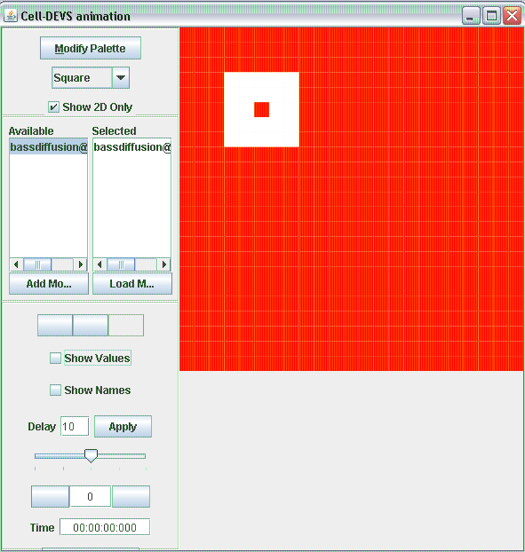

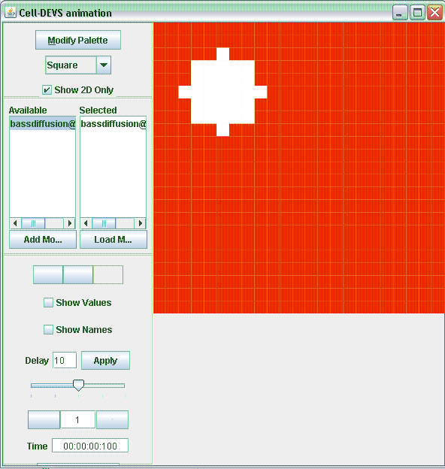

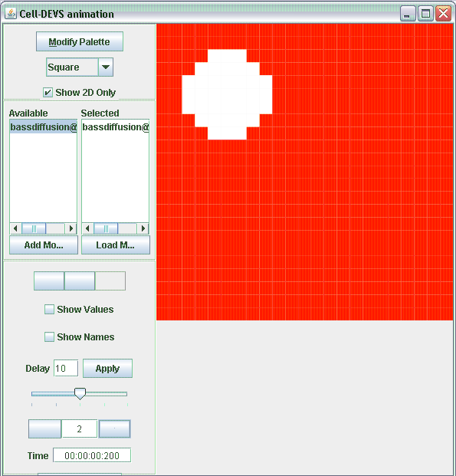

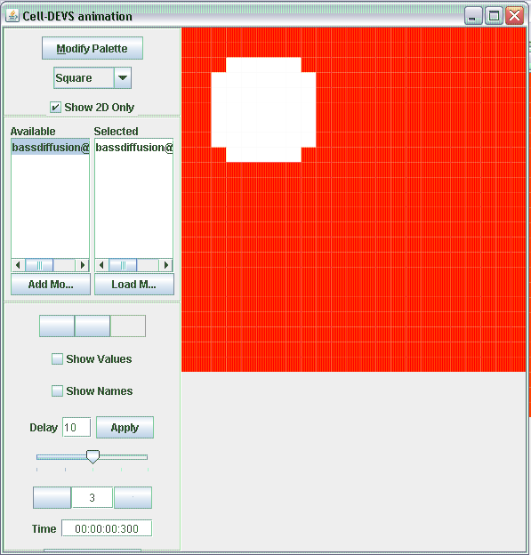

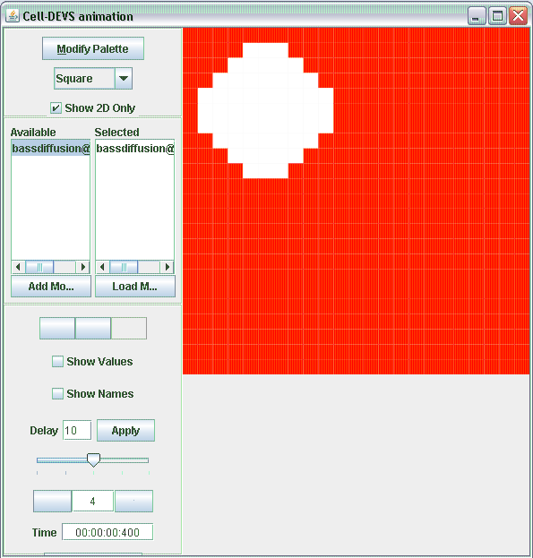

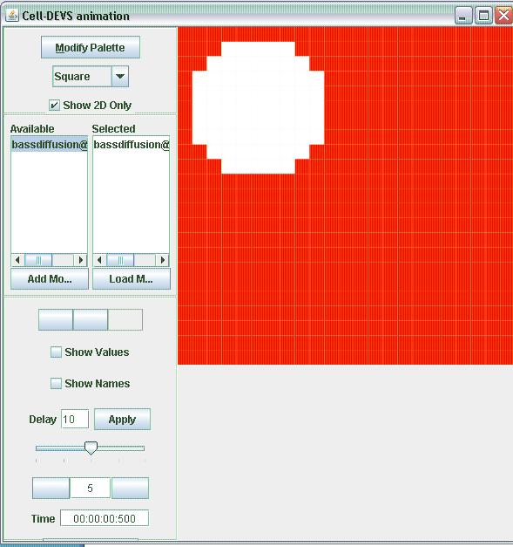

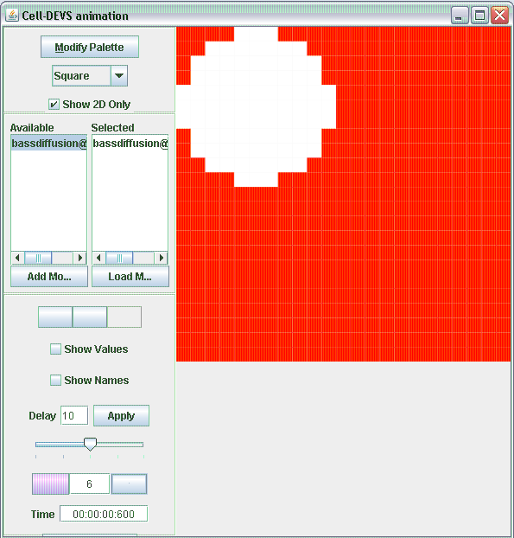

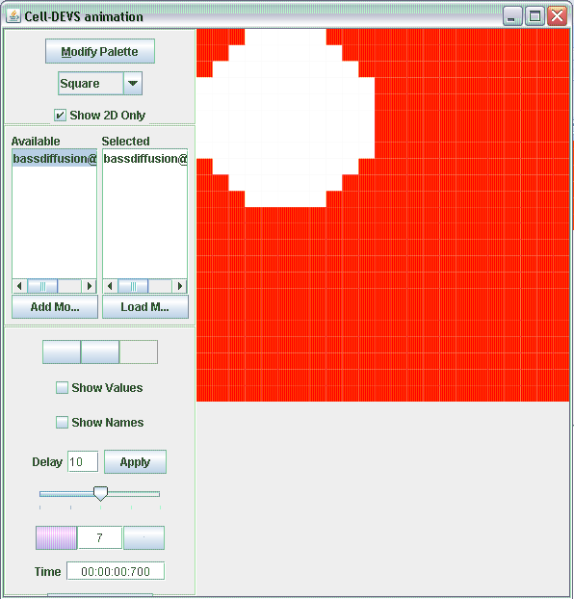

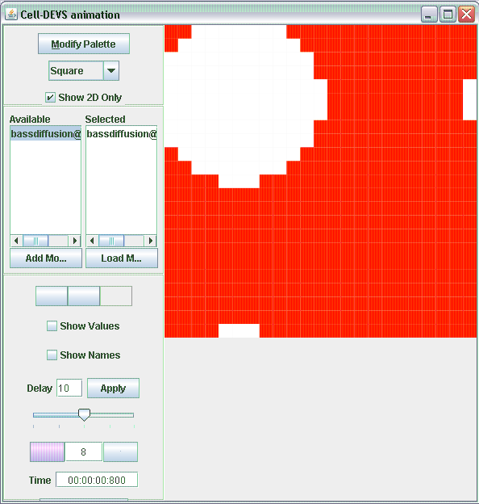

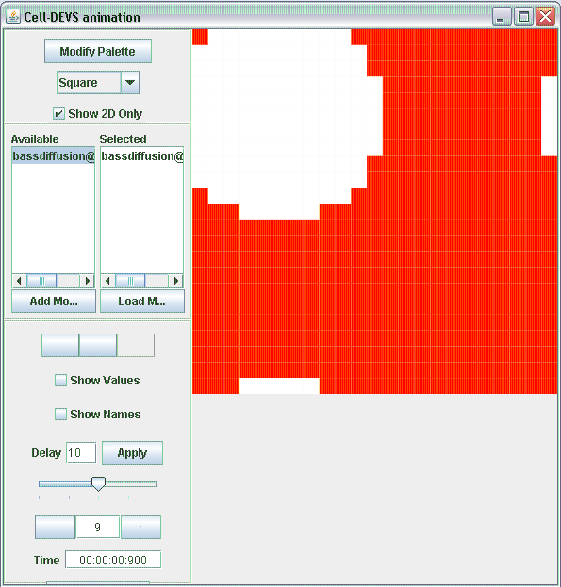

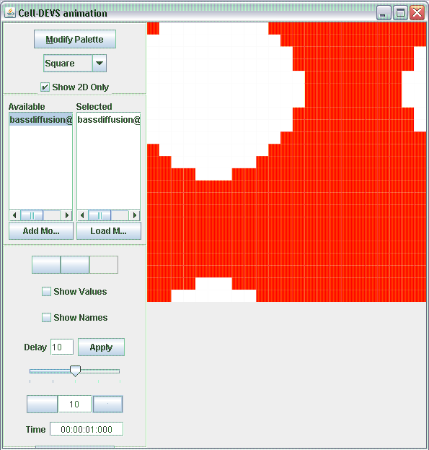

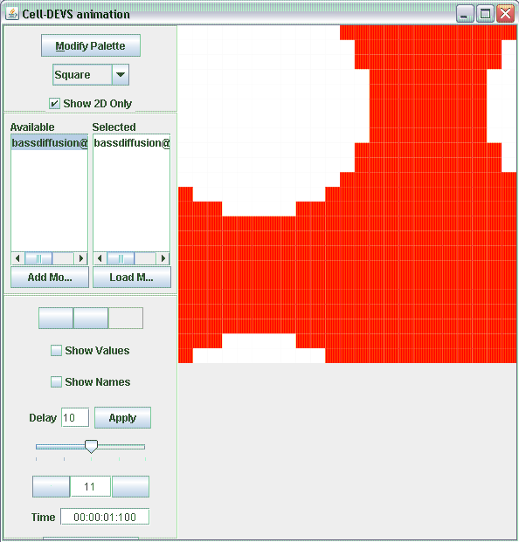

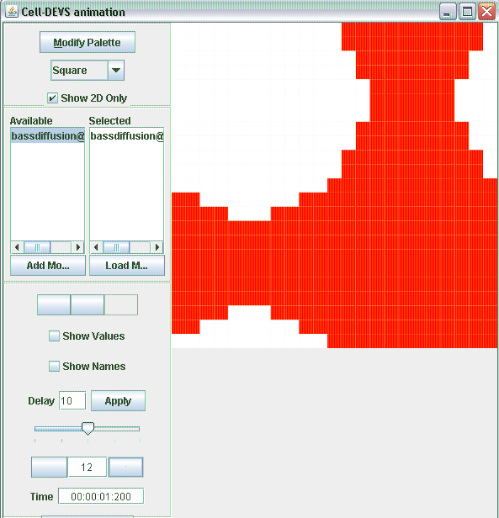

This process will continue until all blocks are whit, meaning that everyone has adopted the innovation.

**Bonus: DEVS-View**

We did not know how to simulate it properly but we have included the files and tried it.